**Task 11: Setting up and Exploring a Free VM in Google Cloud Platform**

*Submitted by*

**RAGILA V V**

*Submitted on: 20-03-2024*

*Course: Cyber Security Analyst*

**ICT Academy of Kerala**

**Step 1: Sign in to Google Cloud Console:**

* + Navigate to the Google Cloud Console website: <https://console.cloud.google.com/>
  + Sign in with your Google account credentials.

**Step 2: Navigate to Compute Engine:**

* From the left-hand side menu, select "Compute Engine".

**Step 3: Create a new VM instance:**

* Click on the "Create" button.
* Fill in the necessary details for the VM instance.
* Selected the "E2-micro" machine type for the free tier.

**Step 4: Configure the boot disk:**

* Chose Debian GNU/Linux 10 as the operating system.
* Changed boot disk type to standard persistent risk

**Step 5: Configure firewall rules:**

* Allowed SSH access.

**Step 6: Review and create:**

* Reviewed the configuration settings and clicked on "Create".

**Step 7: Wait for the VM to start:**

* Waited for a few minutes for the VM instance to start.

**Step 8: Note the IP address:**

* Noted down the external IP address assigned to the VM.

External IP: 34.125.216.51

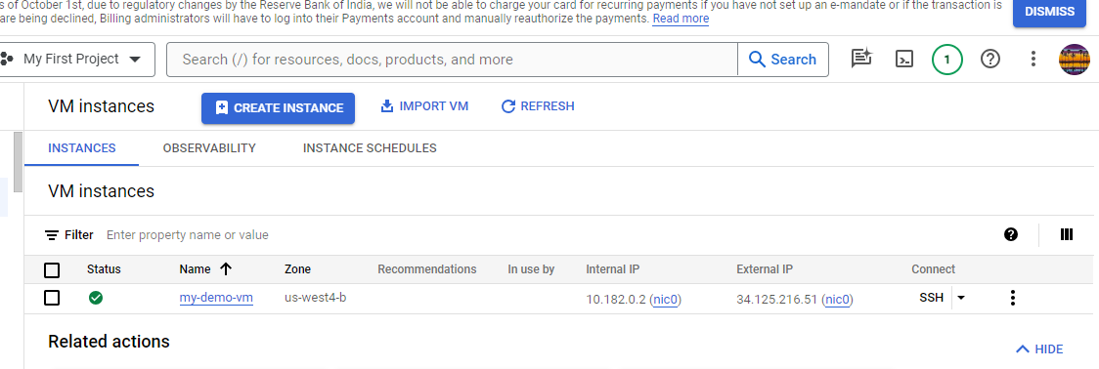

**Step 9: Ping the VM from Kali Linux:**

* Opened a terminal in Kali Linux.
* Used the ping command to check connectivity to the VM.

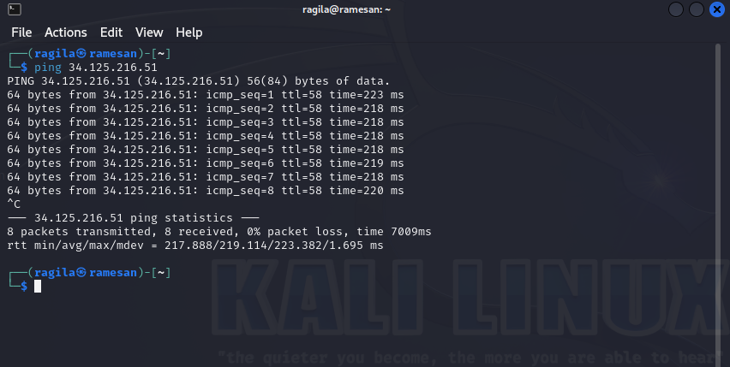

**Step 10: SSH into the VM:**

* Used SSH to connect to the VM from Kali Linux.

**Step 11: Run ip a command:**

* Ran the **ip a** command on the VM 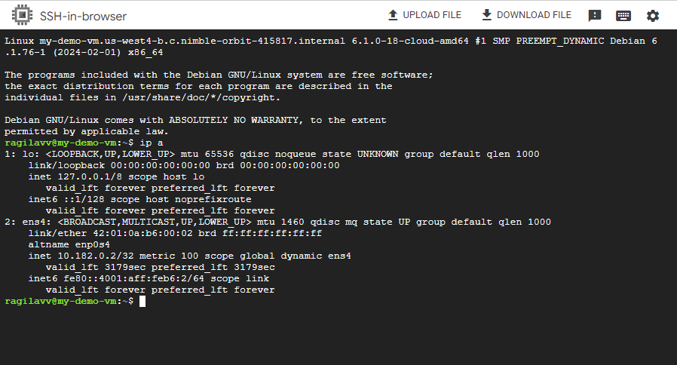

**Step 12: Find your public IP:**

* Used a search engine to find my public IP address.

Public IP: 59.88.247.234

**Step 13: Ping your public IP from the VM:**

* Used the ping command to check connectivity to my public IP address from the VM.

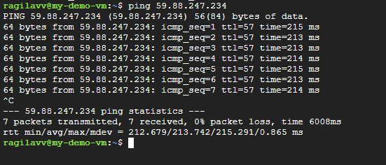

**Step 14: Explore the VM:**

* Navigated through directories and checked system information.

**Step 15: Shut down the VM:**

* Shutdown the VM from the Google Cloud Console.

**Step 16: Destroy/terminate the VM:**

* Deleted the VM instance from the Google Cloud Console.

